Salt Shaker’s Newsletter

Winter 2012 - Spring 2013
Muriel Taylor, Editor
Website: http://ssbs.weebly.com

Completion of Fall 2012 Sessions
I praise and thank God for walking the Salt Shakers through the Fall 2012 sessions (from September to December 2012). Our study focused on “What Happens When Christian Women Pray.”
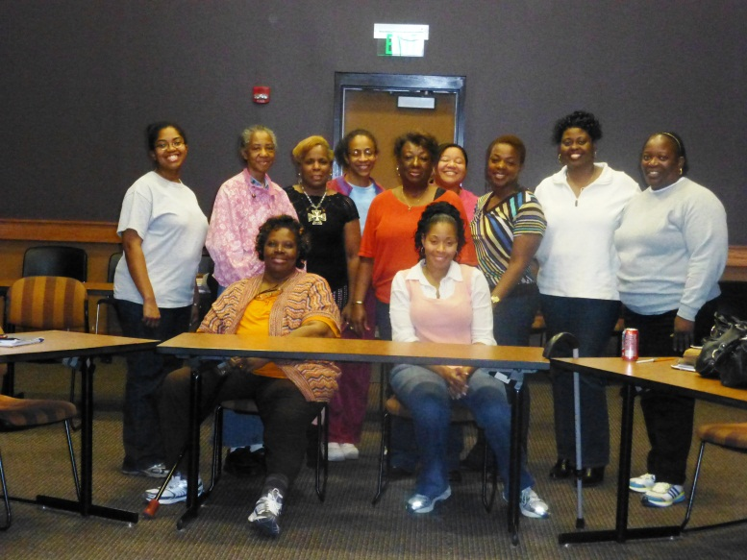
(From left to right: Katrina Key, Linda Martin, Janet Colbert, Kiwayna Williams, Birdie Nunnally, Katrina Shepherd, Ebony Suggs, Daphne Crenshaw, Melissa Johnson. Seated from left to right: Mable Williams and Rachel Richardson).
Some Topics Discussed:
Prayer Is the Answer: It doesn’t Take So Long; Forgiven as We Forgive: Praying in One Accord; How to Pray in God’s Will; God Never Makes a Mistake. We also discussed How and When To Pray, To Whom Should We Pray, and The Results.
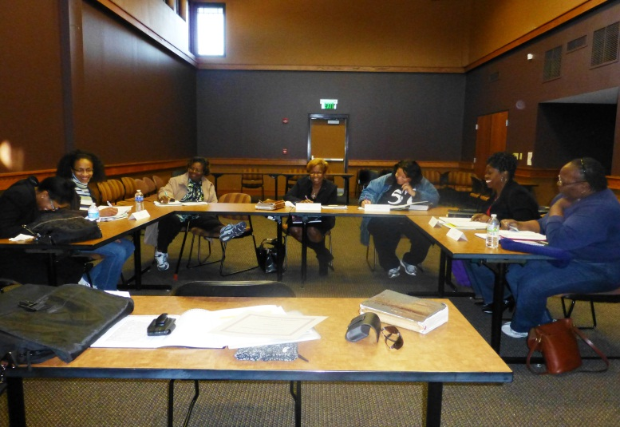
There were several lively interactions on “exclamatory” prayers and praise reports from journaling “supplications”. 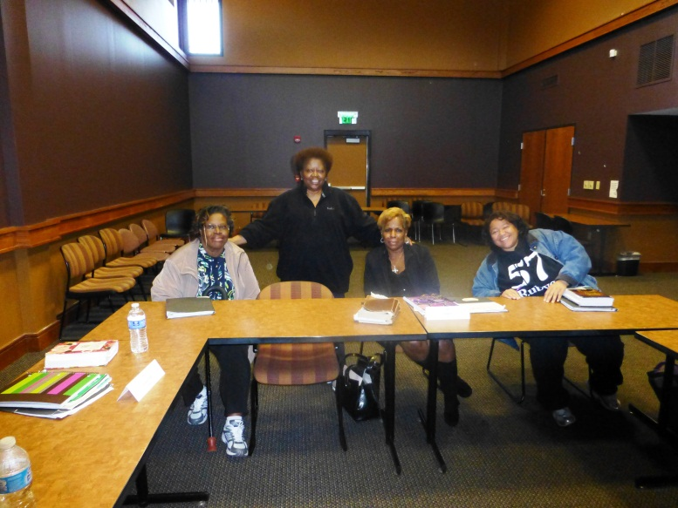
(Left to right: Mable Williams, Muriel Taylor, Janet Colbert, and Katrina Shepherd)
Each session proved encouraging and uplifting as we continued to teach God’s Word and share experiences and personal testimonies.
IMPORTANT INFORMATION
The Spring 2013 7-week session will run from Saturday, February 9th to Saturday, May 4th (Semi-monthly), 1:00 PM to 3:00 PM at Brown Baptist Church’s Mother Lucille Smith Annex Building (located next door to the church on Stateline Road.)
Registration is required for attendance. To ensure adequate seating, all registration must be done online by accessing the Salt Shakers website at http://ssbs.weebly.com/. Registration begins December 28, 2012 and ends January 31, 2013.
To register online, go to the Salt Shakers website, access the Registration Information page. Once you have completed and submitted the form, you will receive an email confirming your seating in the Fall class. If you do not have access to email, you will need to call me and let me know that you desire to register for the class (901-287-9166).All other pertinent information, complete class syllabi, will be located on the website.
Sorry – no children are allowed at these classes.
This spring we will study:

The Weight of Your Words
Measuring the Impact of What You Say
The Word of God tells us in Proverbs 18:21 that, “Death and life are in the power of the tongue: and they that love it shall eat the fruit thereof.”
In this class, we will learn that transforming our tongues requires supernatural strength and how God uses the indwelling Holy Spirit to stimulate growth that produces spiritual, victorious strength. We will discuss the five principles that make us more aware of the gravity of our words. We will also discuss “Murmuring and Contentious Words,” and “The Ego in Our Mouths.
All pre-reading assignments for each class will be noted on the website. There is no need to purchase books, however, you will need to bring a writing/note tablet, pen, and Bible.
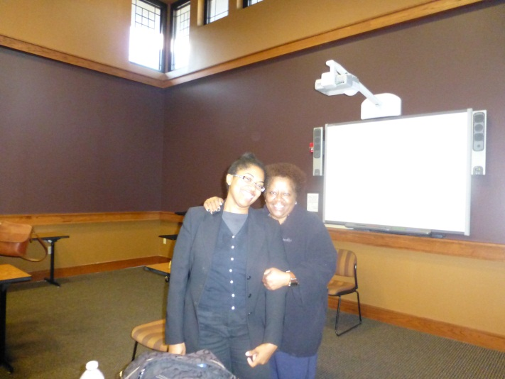
Katrina Shepherd & Mrs. Taylor

We look forward to continually expanding the Salt Shakers classes to as far as the Lord allows. If you are serious about your spiritual growth in the Lord, please take time to check out the site and sign up to attend our upcoming classes – we welcome you!

Matthew 5:13
You are the salt of the earth, but if salt has lost its taste, how shall its saltiness be restored? It is no longer good for anything except to be thrown out and trampled under people's feet.
Become a part of the Salt Shakers Women’s Bible Study – it will change your life!

