Salt Shakers
Spring/Summer 2013 Newsletter

Weekly Newsletter

Lorem ipsum dolor sit amet, consectetuer adipiscing elit. Ut e

We praise God for the spring 2013 sessions. Our study focused on “The Weight of Your Words: Measuring the Impact of What You Say.” There was great attendance, new faces, fun, and wonderful fellowship. The Lord spoke to our hearts on various subjects, such as, Maliciously Speaking: Gossip & Slander - Catastrophic Cousins, and The Ego in Our Mouths: Boasting, Flattery, & Exaggeration.

At the beginning of our session, a black wrist band was distributed to each attendee. The purpose of wearing these bands daily was to remind us to focus on two specific scriptures: Psalms 141:3 and Psalms 19:14. As we reflected on these verses each day of the week, they would remind us to “weigh” our words in our personal dealings with others. We had some uplifting and funny stories to share throughout these sessions. These forms of real testimonies caused us to bond and grow closer in our relationship with one another, and with the Lord. I’m looking forward to more of this type of fellowship in our future sessions.

Salt Shakers, as you go about your summer vacation, I would like you to remain focused on some things that will continue to strengthen and guide you:
Remember to weigh your words!
Reminisce the verses we memorized: “Set a watch, Oh Lord, before my mouth; keep the door of my lips.” “Let the words of my mouth and the meditation of my heart, be acceptable in Your sight, Oh Lord, my strength and my Redeemer.” Represent Christ every day; yes, even during vacations!
Be a Balcony Person and Not a Basement Person This Summer:

Balcony People: People hanging over the rail of our lives, cheering us on! Their words give strength, courage, and a great surge of confidence. They are the people who are hanging over the railing shouting, “You can do it! I believe in you!”
Basement People: People who pull others down with comments like, “You’re not gonna make it.” They tell us we can’t do such and such. They drop subtle or not so subtle hints about our inferior qualities, and thoroughly damage our personhood.

It’s not the amount of people, but the high caliber and level of credibility that really counts. After all, it only takes one “basement person” to drown us in the murky waters of failure and discouragement. Why not then, the reverse? It only takes one “balcony person” to lift us up and restore our sense of well-being.

Concentrate on being a balcony person to others this summer!

As Christians,
We should live in relationships with people
in such a manner that even when we leave a room,
People will miss us.
And when we are gone,
and our funeral is held,
Someone will cry,
Someone will deeply miss us.

*Resource: Balcony People, Joyce Landorf

Fall 2013 Registration
Salt Shakers Spring/Summer 2013 Newsletter
Muriel Taylor, Instructor & Managing Editor
Online registration for fall classes will begin June 28, 2013 and will close August 24, 2013. To register, go to the Salt Shakers website at www.ssbs.weebly.com, click on Registration Information, complete entire form, and click Submit. Once this has been done, you will receive an email from me confirming your seating in the class and other pertinent information regarding assignments. Please take the time to read all information on the Salt Shaker’s website before registering; that way, you will know all that’s necessary before you make your final decision: Dates, Time, and Location.
There is no cost to attendees for these classes. However, the instructor’s budget for preparing class documents and purchasing objects for lesson application for each registrant (bags, badges, packages, other class materials), can be somewhat costly. Therefore, we ask only those who are really serious about studying God’s Word register to become a part of this study group. If you have any specific questions you would like to ask before registering, I will be more than happy to speak with you. I can be reached at 901-287-9166 or email me at muriel.taylor4@gmail.com.
Theme: Hand Me Another Brick
[Date]
Scripture: Based on the Book of Nehemiah

Romans 15:4 tells us, “For whatever things were written before were written for our learning, that we, through the patience and comfort of the Scriptures might have hope.”

Nehemiah faced some of the same issues you and I face today, and there is much we will learn and discuss in our upcoming sessions; topics such as:

- How to Handle a Touchy Boss
- How to Handle Executive Discouragement
- What to Do with Unwarranted Criticism
- A Leader – From the Knees Up
- How to Handle a Promotion
- Operation Intimidation
- Knocked Down, but Not Knocked Out
- Putting First Things First

This class will provide wise and practical strategies for coping with inevitable obstacles such as these:

- Unprecedented losses and damages
- Attacks from jealous adversaries
- Nerve-shattering financial pressures
- Relentless time constraints
- Personality conflicts and misunderstandings

As we share with one another during these class sessions, I am sure there are times you will want to cry, laugh out loud, and maybe do cartwheels – anything is possible. I only ask that you come prayerfully, humbly, and ready to receive all that the Lord has for you. If you desire a closer walk with the Lord, and you are yearning for God to use you to His glory, this class is for you.

COME JOIN US!
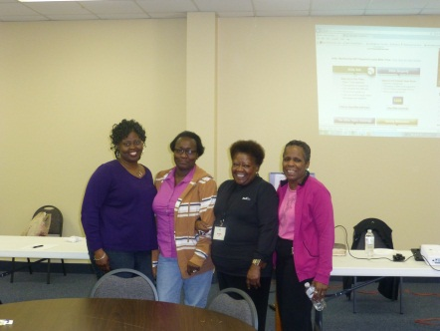

You’ll Be Glad You Did!
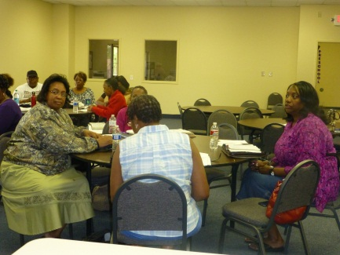

I’ll Be Looking For You!
