Salt Shaker’s Newsletter

## 

**Muriel Taylor, Editor**

**Website:** [**http://ssbs.weebly.com**](http://ssbs.weebly.com)

Fall 2012

Why “Salt Shakers”?

The Salt Shakers Women’s Bible Study was born out of Matthew 5:13, “You are the salt of the earth.” The scripture is speaking to born-again believers. Because we are the flavor of society, the Salt Shakers will use their God-given abilities and gifts to shake up this culture. This can only be accomplished as we continue to eat, breathe, and live out the Word of God in our everyday lives. 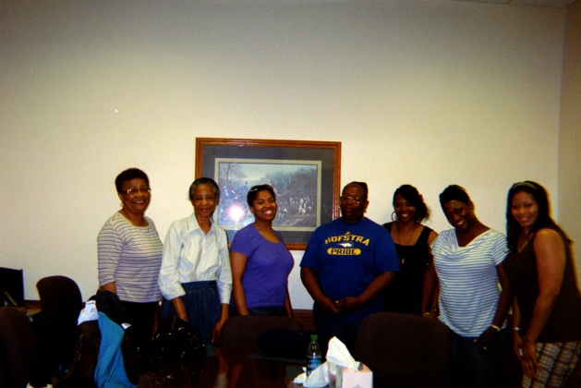

When we order our steps according to the Word of God and begin living out His principles, we begin to **shake up** things!!  Only then will the world begin to really thirst for what we have to offer them.



**Why “Salt”?**

Tony Warren states its purpose plainly:  "Salt in scripture carries a two-fold signification. The positive attribute of salt is that it is the **flavor** which makes things good. The negative attribute of salt is that of its use in making something barren or without worth. (Warren, the Mountain Retreat, 2001)  Only born-again believers provide the **flavor** that the world is starving for.

**When was the last time?**

When was the last time you *allowed* the Lord to use all that passion and Bible knowledge you’ve been bottling up? Waiting for the “right” time and place to release that unopened package to those deserving of it? What are you waiting on? The time is now! Time to get into God’s Word! Time to act out God’s Word! I challenge you; no, I dare you to allow the Lord full control of your life.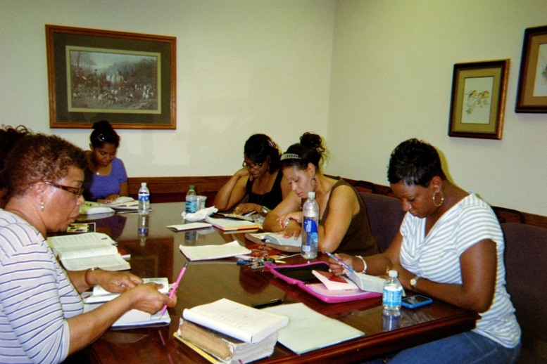

I dare you to give Him full reign of your life in order to allow the Holy Spirit to act out the Word of God through you. The world is thirsting - the world is yearning for someone to go out of their way to give them a drink of the Water of Life; will you be that someone that the Lord can use?

Salt Shakers consist of women from every walk of life who are not satisfied with being mediocre Christians. Some are drinking milk. Some are eating meat. Some are somewhere in between. But they all have something in common: *a strong love and desire to seriously delve into the Scriptures!*

**IMPORTANT INFORMATION**

The Fall 2012 Salt Shakers Women’s Bible Study will commence on Saturday, September 8, 2012 from 1:00 PM to 3:00 PM at the Whitehaven Library Classroom located on the corner of Raines Road and Millbranch.

Online registration for the Fall 2012 class opens on Saturday, June 30, 2012 through Saturday, August 11, 2012. Due to limited seating, **registration is required for attendance**.

To register online, go to the Salt Shakers website (when registration opens on August 11th), access the Registration Information page. Once you have completed and submitted the form, you will receive an email confirming your seating in the Fall class. If you do not have access to email, you will need to call me and let me know that you desire to register for the class (901-287-9166).

All other pertinent information, complete class syllabi, will be located on the website.

The title of this 8-week session is:

**What Happens When Women Pray!**

I am very excited about what the Lord has given me for this class. I believe you will definitely receive a blessing.

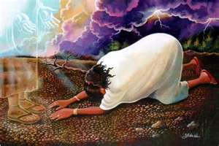

The reading assignments for each class will be noted on the website effective June 30th. There is no need to purchase books for this class, however, you will need to have a writing/note tablet, pen, and Bible.

**Matthew 5:13**

You are the salt of the earth, but if salt has lost its taste, how shall its saltiness be restored? It is no longer good for anything except to be thrown out and trampled under people's feet.

**Become a part of the Salt Shakers Women’s Bible Study – it will change your life!**